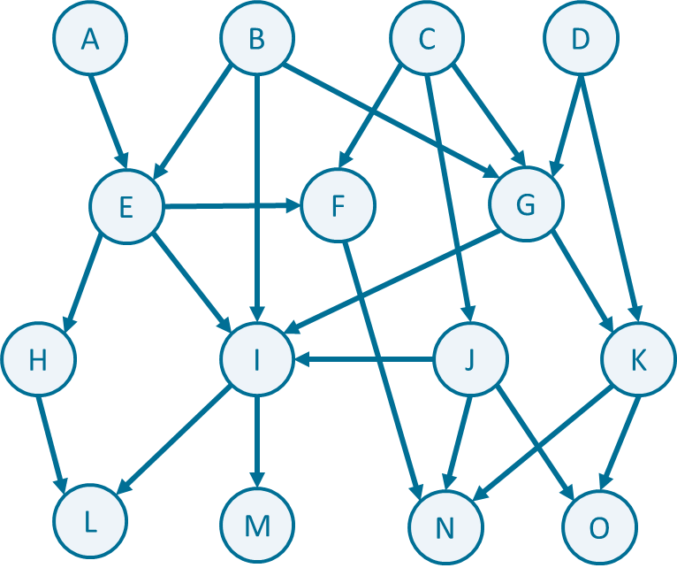

Complete uninformed search algorithms given below

In **data-driven search**, consider arcs from the left side to the right side in a **counterclockwise direction**

In **goal-driven search**, consider arcs from the left side to the right side in a **clockwise direction**

|  |  |  |
| --- | --- | --- |
| Goal-driven Depth-First Search  Search start node – L  Search goal node - C | | |
| Iteration | OPEN | CLOSED |
|  |  |  |
|  |  |  |
|  |  |  |
|  |  |  |
|  |  |  |
|  |  |  |
|  |  |  |
|  |  |  |

|  |  |  |
| --- | --- | --- |
| Data-driven Breadth-First Search  Search start node – B  Search goal node - L | | |
| Iteration | OPEN | CLOSED |
|  |  |  |
|  |  |  |
|  |  |  |
|  |  |  |
|  |  |  |
|  |  |  |
|  |  |  |
|  |  |  |

|  |  |  |
| --- | --- | --- |
| Data-driven Depth-Limited Search  Search start node – C  Search goal node – M  Depth limit = 2 | | |
| Iteration | OPEN | CLOSED |
|  |  |  |
|  |  |  |
|  |  |  |
|  |  |  |
|  |  |  |
|  |  |  |
|  |  |  |
|  |  |  |

|  |  |  |
| --- | --- | --- |
| Goal-driven Depth-Limited Search  Search start node – O  Search goal node – B  Depth limit = 3 | | |
| Iteration | OPEN | CLOSED |
|  |  |  |
|  |  |  |
|  |  |  |
|  |  |  |
|  |  |  |
|  |  |  |
|  |  |  |
|  |  |  |

|  |  |  |  |  |
| --- | --- | --- | --- | --- |
| Bidirectional Search  Search start node – D  Search goal node - M | | | | |
| Iteration | OPEN | CLOSED | OPEN | CLOSED |
|  |  |  |  |  |
|  |  |  |  |  |
|  |  |  |  |  |
|  |  |  |  |  |
|  |  |  |  |  |
|  |  |  |  |  |
|  |  |  |  |  |
|  |  |  |  |  |
|  |  |  |  |  |
|  |  |  |  |  |

|  |  |  |  |  |
| --- | --- | --- | --- | --- |
| Bidirectional Search  Search start node – B  Search goal node - O | | | | |
| Iteration | OPEN | CLOSED | OPEN | CLOSED |
|  |  |  |  |  |
|  |  |  |  |  |
|  |  |  |  |  |
|  |  |  |  |  |
|  |  |  |  |  |
|  |  |  |  |  |
|  |  |  |  |  |
|  |  |  |  |  |
|  |  |  |  |  |
|  |  |  |  |  |

**Complete algorithms by storing a solution path**

|  |  |  |
| --- | --- | --- |
| Data-driven Depth-First Search  Search start node – C  Search goal node - L | | |
| Iteration | OPEN | CLOSED |
|  |  |  |
|  |  |  |
|  |  |  |
|  |  |  |
|  |  |  |
|  |  |  |
|  |  |  |
|  |  |  |
| **Solution path:** | | |

|  |  |  |
| --- | --- | --- |
| Goal-driven Breadth-First Search  Search start node – O  Search goal node - D | | |
| Iteration | OPEN | CLOSED |
|  |  |  |
|  |  |  |
|  |  |  |
|  |  |  |
|  |  |  |
|  |  |  |
|  |  |  |
| **Solution path:** | | |